In this issue:
- Flexible Appointments Pg 1
- Connecting Your Care Pg 1
- Medical Students Pg 1
- Primary Care Networks Pg 2
- Over the Counter medicines Pg 2
- Staff Changes Pg 3
- Thank You! Pg 3

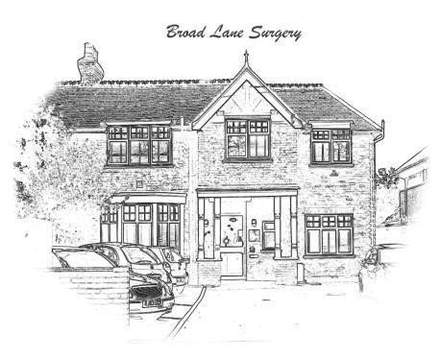
BROAD
LANE
SURGERY

Newsletter Issue 9 (Edited by PPG)
FLEXIBLE APPOINTMENTS

Our pilot offering pre-booked Saturday morning GP appointments has proven to be popular with patients and will continue for the time being. It will be subject to further review in the future.
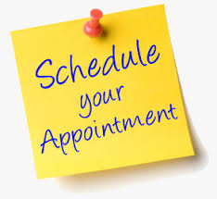
Patients now have the ability to book 24 hour and 48 hour GP appointments online as well as less urgent appointments up to 4 weeks in advance. In addition, from week beginning 25/06/2019, there will be a number of same day GP appointments available to book online. In total, this will mean 25% of all GP appointments will be available to book online with the remaining 75% of the surgery’s appointments available to book in person or over the phone. If you do not already have online access, please ask at reception for details. All patients will need to provide new ID when signing up.

CONNECTING YOUR CARE

“Connecting your Care” is a new secure system launched in April 2019 which allows clinicians involved in direct patient care at hospitals and in GP practices to see the latest data on a patient held by the GP or the acute hospital. Hospital doctors and nurses will be able to view GP owned patient data and vice versa, in real time. No data will be able to be updated, stored or printed other than where it is owned and maintained. This will enable doctors and nurses to have the most up to date view of patient information including diagnoses, allergy information, medications, test results, appointments, etc. thus supporting safe patient care. By default, all patients will be included in this system. Patients can choose to opt-out of the data sharing service by visiting our website (www.broadlanesurgeryhampton.co.uk) and selecting the opt-out form under the Connecting Your Care tab, or by clicking on this link Connecting Your Care opt-out. Alternatively opt-out forms are available from the surgery.

MEDICAL STUDENTS AND COMMUNITY PROJECTS.
For the last year we have been hosting 3rd year Imperial College Students as part of their Primary Care and Community placement. They have really enjoyed working with the surgery and speaking to patients. We are very grateful to those patients who have given their time to see them - they have found the learning incredibly valuable. They have also completed Community Action Projects - working on developing leaflets with Citizens Advice on benefits information, and also working on strategies to help patients remember their medication and any allergies by creating 'medication pockets.' We are looking forward to continuing to teach undergraduate medical students at the surgery.

PRIMARY CARE NETWORKS

You may have heard on the news that Primary Care is changing. From 1st July 2019 we will be working together with our local surgeries as a Primary Care Network. Primary Care Networks will not be legal entities; practices will continue to be autonomous and will collaborate to support their combined patient populations. Over the next few years, new exciting job roles will be introduced by the Networks enabling the surgery to deliver some patient care in new ways. These roles will include clinical pharmacists, social prescribers, physician associates, physiotherapists & paramedics. New technology will continue to evolve with an aspiration of enabling virtual consultations by 2021. GP Practices in Richmond are planning to come together in 5 geographically contiguous networks which will all be administered by the Richmond GP Alliance which is our local GP Federation. We will keep you updated on developments in our next Newsletter.

OVER THE COUNTER MEDICINES

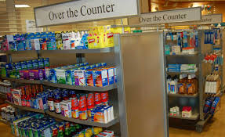
NHS England has issued guidelines concerning over the counter medicines for a range of minor health concerns. A GP, nurse or pharmacist will not generally give you a prescription for certain medicines that are available to buy in a pharmacy or supermarket, even if you qualify for free prescriptions. The patient leaflet which includes a list of conditions for which this applies can be accessed at over-the-counter-patient-leaflet or by visiting our website (www.broadlanesurgeryhampton.co.uk) and selecting Over the Counter medication tab.

How can you help yourself?
- Visit your local pharmacy team who are qualified healthcare professionals and will be able to help with many health concerns, give clinical advice and help you choose the most appropriate over the counter medicine and treatment. They will also advise you on the most suitable products to have at home for children.
- Keeping a few useful medicines at home, such as painkillers, indigestion medicines, seasonal remedies for cold and hay fever, sun block and after sun, plus basic first aid items like plasters and antiseptic creams, so you can treat many common conditions immediately.
The GP’s have been informed that the Department of Health has contingency plans in place in the event of a no deal Brexit. PLEASE DO NOT STOCKPILE MEDICATION.

STAFF CHANGES

Our Senior GP Partner, Dr. Bhatia is taking a well-earned sabbatical starting at the beginning of July 2019.
We also welcome Julie Longstaff who has joined Broad Lane Surgery as Practice Pharmacist.

Julie will be in the surgery each day to support the GPs and answer patient queries.

We welcome Dr. Sapna Gulati who has joined the practice as a salaried GP. Many patients will know Dr. Gulati as she has operated as a Locum for us many times in the past.

Dr. Bhatia’s clinical sessions will be covered by Drs. Adhikari, Rashid and Gulati for the duration of her sabbatical.

THANK YOU!

We are very grateful to all those patients who turn up promptly for their appointments – THANK YOU. This does facilitate the smooth running of the surgery and helps to ensure the clinicians see as many patients as possible.

Disappointingly there are still too many occasions where patients do not attend their appointments. Analysis shows that of those patients who fail to attend, 25% booked their appointment on the same day and a further 18% booked their appointment in one of the 24/48 hour slots.

Finally if you have any topics you would like included in future newsletters please pass on the details at reception for the attention of Linda Garland. Alternatively you can email the surgery on ricccg.adminbroadlanesurgery@nhs.net and we’ll see what we can do!

